**Garrett Little**

Final Game Design Document

November 19th, 2020

Working Game Title: **Trenches**

**Introduction/Inspiration:**

Growing up, I was a huge fan of the ‘Ted Ginn Return Man Game.’ As an avid sports fan, it was awesome to be able to play a game on the computer that looked as good as it did. For my own game, I would love to take the elements from that game, and to bring a breath of fresh air to it.

The name ‘Trenches’ is based off the ‘trenches’ in real life football. This refers to the offensive or defensive line where some of the most physical, and most underappreciated parts of the game happen. The game itself has no ‘narrative’ per se, it is more so a game where you try to achieve a high score and/or get the furthest in the game (highest level.)

**Gameplay Description:**

Ideally, I would love for **Trenches** to be a top down, scrolling game where the player controls a football player. The goal would be for the player to weave in and out of oncoming defenders and to avoid getting tackled. Along the way, the player could pick up power-ups that would help to make the game a little bit easier. The user would use the arrow keys, or the ‘awsd’ keys in order to control the direction the player runs. I might include a way for the player to ‘jump’ or ‘spin’ as well, just to make the game a little more dynamic.

**Visual Style:**

Going into this, I am not sure how difficult it’s going to be to achieve the visual style that I have in my head. Ideally, I want some sort of ‘8-bit’ or pixelized style to my game. I want their to be a scrolling field with the appropriate hash marks. Also, I would like there to be a set of bleachers and fans on the sides of the game that play some sort of crowd noise to increase the immersion. Also, I would possibly like to add some sort of scoreboard system, and some animations when the player scores a touchdown, like possibly having confetti go off, or having flashing text in the endzone. Also, if there is a way to add achievements into the game, I’d love to do that as well, just to give the game a replayability factor.

Again, I am not sure how hard this is going to be to achieve, so this is more so an idealistic view. I am hoping that I can use Illustrator to create some basic characters, and a field, but we will see how successfully that plays out. Below is the sort of ‘style’ I want my game to have. This is a bit more detailed than I want mine to be, but the overall cleanliness and aesthetic is one in which I would like to aim for. However, I might end up going for a more ‘flat’ style with some clever use of shadows to make things feel a little bit more grounded.

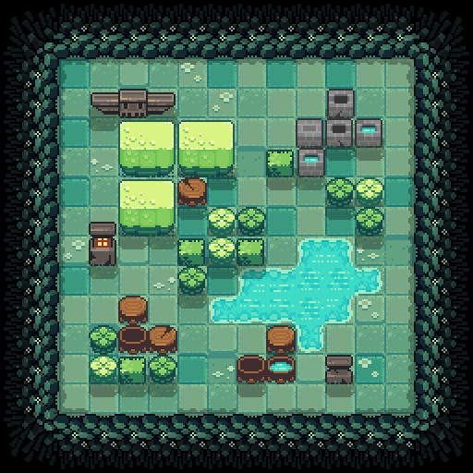 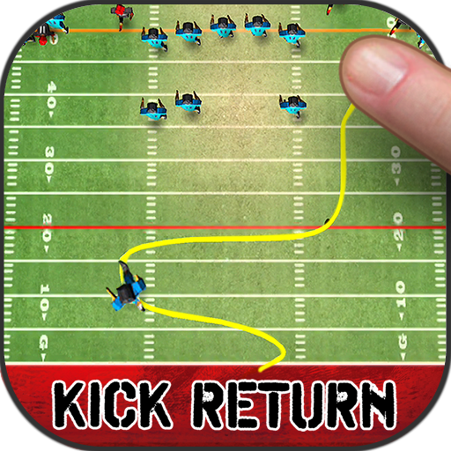

**Audio Style:**

For this game, I want there to be a college football type soundtrack that gives the game a football vibe. Also, I want to implement a whistle at the start of every level, and then crowd noise that plays while you are moving around. When the player scores, I also want to add a ‘Touchdown!!” audio clip that will give the player some sense of accomplishment.

**Sketch:**

**Feature Sets:**

***Low Bar***: Create a top down football game with 2 levels with a scrolling background, working controls, and a scoring system.

***Target:*** Create a top down football game 4 levels with a scrolling background and defenders who try to tackle you. Working controls, a scoring system, and audio that plays at the appropriate times.

***High Bar:*** All of the above fully polished, a refined and professional visual style, animated characters, animations for scoring, implementation of a high score list, achievements, etc.

**Final Note:**

While this idea sounds super fun to me, I don’t know how realistic it is in Construct, especially with the free version. However, I am excited to tackle this challenge and see what I can put together!

*fingers crossed*